Black

**Visit Southeast Montana Board of Directors**

The **MISSION** of Visit Southeast Montana is to increase visitors to Southeast Montana by increasing awareness of our region, showcasing our cultural heritage, developing memorable experiences and educating our residents about the economic benefits of tourism. [www.SoutheastMontana.com](http://www.SoutheastMontana.com)

**April 13, 2017 – 10 a.m. – 3 p.m.**

**Big Horn County Historical Museum**

**1163 3rd St. East, Hardin, MT**

**Meeting Agenda**

1. Welcome and Introductions - Chip Watts (Board Chair) 10:00
   1. Welcome to Hardin (Mayor Jack Lane)
2. Public comments on items NOT on the agenda (limited to 3 minutes per speaker)
3. Approval of February 7, 2017 Meeting Minutes (pages 3-5) ACTION
4. Financial Overview – Megan 10:10
   1. Variance report and Financials, March, 2017 (pages 6-7) ACTION
   2. External audit (attached)
5. STRATEGIC DISCUSSION – Brenda and John 10:25
   1. Proposed FY18 Marketing Plan & Budget ACTION
      1. Present revised marketing plan for approval
      2. Present proposed FY18 budget (as approved by Executive Committee)
6. STRATEGIC GOALS 11:15
7. **Produce Quality Marketing Initiatives** 
   * 1. Brief Marketing Update – Brenda & Aly
     2. FY17 Marketing Calendar & Destination Analytics survey summary - Brenda
8. **Develop Marketing Partnerships…**outside the region
   * 1. Dino Trail update (Brenda)
9. **Grow In-Region Partnerships…**to connect to constituents
10. Board of Directors bios and photos (Brenda)
11. Partner e-blasts (Brenda)
12. **Support Tourism Product Development**
13. Custer Loop (Dennis Kopitzke)

LUNCH BREAK 12:00

1. Committee/Task Force and Board Reports 12:45
   1. Executive Committee—Chip
      1. Board roster and committees – Openings/Terms (pages 8-10)
      2. Applications (pages 11-18) ACTION
      3. Conflict of Interest & Whistleblower policies (pages 19-22) ACTION
   2. Marketing Grants—Dale/Brenda
      1. New grant update
      2. Balance available remains at $2,679
      3. Recommendations for new grant application language ACTION
   3. Evaluation Committee
      1. Update on Agency of Record RFP process
   4. Legislative Update/Tourism Matters (John Laney)
   5. Other announcements
      1. Updates from around the region
   6. Board Meeting Schedule: All meetings 10 a.m.-3 p.m. unless otherwise noted. All times subject to change
      1. June 15 (Miles City)
      2. FY18 calendar
2. Meeting Adjourns

**NOTE:**

Please plan for a brief tour of the host facility, Big Horn County Historical Museum 2:00

NOTE: Other than the meeting starting time, times listed are approximate and agenda items may be rearranged. Public comment is welcome on all items.

***Thank you to our Title Sponsor*** [***Holiday Station Stores***](http://www.holidaystationstores.com/)

[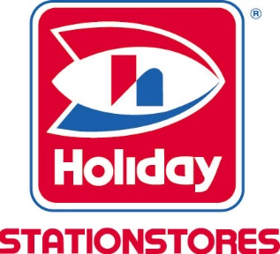](http://www.holidaystationstores.com/)

***Thank you to our Corporate Partners***

[***ZooMontana***](http://www.zoomontana.org/)

***[Miles City Chamber of Commerce/TBID](http://milescitychamber.com/)***

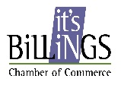

Visit Southeast Montana is managed by the Billings Chamber of Commerce