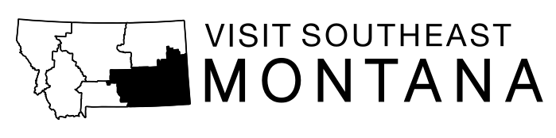

Application and Qualifications for
Visit Southeast Montana Board of Directors

The mission of Visit Southeast Montana is to increase visitors to Southeast Montana by increasing awareness of our region, showcasing our cultural heritage, developing memorable experiences and educating our residents about the economic benefits of tourism.

INTRODUCTION: Southeast Montana Tourism Region (SEMT) board members are chosen from individual applicants from within the region who exhibit a desire to serve, coupled with a knowledge and connection to the travel and tourism industry. They should be highly motivated individuals and community leaders committed to the furtherance of SEMT’s objectives to market the region as a destination: not merely their areas on influence. The SEMT board makeup will consist of a balance of gender, industry types and geographic location. If chosen as a board member, it will be your obligation to creatively, respectfully, expeditiously and professionally move our region forward and showcase its wonderful attributes to increase visitors and visitor spending.

The SEMT Board of Directors is an independent body in contract with the state to manage lodging tax expenditures and in contract with the Billings Chamber/CVB for day-to-day management duties. The SEMT Board is the legal governing body with full fiduciary responsibility for all lodging tax expenditures with the exception of the administrative fee.

The board’s primary functions are to provide strategic direction, engage other stakeholders in the region and set policy. A handful of subcommittees and task groups will provide additional direction in areas of specific need.

PROCESS: Applicants must complete the attached form and submit it by the due date above. Applicants will be screened by the nominating committee. Recommendations by the nominating committee will be made to the full board. The board will then take action to appoint new board members. Staff will contact new board members and inform them of their selection, term, beginning date and orientation date.

BOARD MAKEUP: To operate at the utmost efficiency while being completely representative of the region, the board is of a size and makeup that is strategic in thinking, and engaged. There shall be up to one representative from each county (must reside in that county) and each Indian Reservation (must reside on that reservation and be an enrolled member of that tribe); up to six (6) at large members; one ex officio position for each state designated CVB (in the Southeast Montana Tourism Region) allowing for strong communications and opportunities for marketing partnerships; and up to four (4) ex officio positions for major attractions, communities (officials from chambers, city, and county), or others as deemed essential to the fulfillment of the mission. Membership of the board will be between 14-21 voting members and no more than six ex-officios. There may never be more than two voting members from any one county or reservation. This will assure a balanced board that is representative of the region in its decision making.

BOARD MEETINGS: Meetings will be held at least quarterly with the location of meetings to rotate throughout Southeast Montana. This will provide communities an opportunity to showcase their tourism product and hospitality while allowing board members to fully understand the region they are charged with promoting. Board attendance will be reviewed periodically at which time the Chair of the Board has the discretion and authority to advise those directors not complying with attendance policies that their absence is construed as resignation from the Board. Allowance for extenuating circumstances may be made. Travel expenses to attend these meetings are solely borne by the board member but may be reimbursed as funds are available.

BOARD SELECTION PROCESS: Selection of SEMT board members will take place via a nominating committee of the board on an annual basis. A nominating committee will be engaged year round to identify potential new members. Those candidates would be vetted by the committee and ratified by the board.

BOARD ORIENTATION: Prior to each new board member’s first meeting, a thorough orientation shall be provided and will include the following elements: Board member duties and expectations; bylaws review; conflict of interest policy review to include their signature; mission; financial review; historical perspective of the organization; overview of the tourism assets within the region; marketing plan overview; travel statistics pertaining to the region; trends; insurance coverage; meeting dates and attendance requirements; past successes and current promotional campaigns and more.

BOARD GOVERNANCE RELATIONSHIPS & RESPONSIBILITIES
To Southeast Montana Policy
Your status is that of an individual acting in a governance capacity. You have the right to exert your influence with the Board for approval of actions and policies, but your authority does not go beyond your vote. You have no authority as an individual to commit SEMT to any action or policy.
To the Public
You are an official representative of the regional stakeholders within SEMT. You should defend SEMT against criticism and take steps to remedy conditions that cause justified criticism.
To the Staff
Your responsibility for the SEMT staff is limited to that of advisor. The President/CEO is responsible for hiring, firing, and management functions of all staff members.
To Committees & Task Forces
You have a responsibility to keep informed about the activities of all committees and task forces because you may eventually be asked to study and act on their recommendations. You also have a responsibility to see that all committees and task forces operate within established structure and guidelines.
To the Board
You are a co-partner in the important work of the Board to improve the economic and civic life throughout Southeast Montana. You have assumed a position of public trust. You should disassociate your personal interests from SEMT activities.

To the Program of Work
You must understand the relationship between the Board and SEMT’s plan of action in order to reach established objectives. Remember, SEMT’s marketing plan charts a future course of action, furnishes measurements for performance and serves as a challenge to stakeholders to meet their responsibilities. The liaison with SEMT’s Advertising Agency and other vendors shall be staff working at the direction of the board.
To the Budget
Financial support of SEMT comes from Lodging Tax and potential private sources such as fundraising projects, visitor guide, and annual investments. Southeast Montana operates on a budget approved by the Board. It is the responsibility of SEMT staff to get maximum results from available funds and to operate within the approved budget. The budget, marketing plan and project applications must be approved by the state.

STATEMENT OF GOVERNANCE
- Actively support, promote and participate in SEMT’s mission;
- Ensure steady financial growth through private investments;
- Work with strategic alliance partners to allow our region to move forward;
- Have oversight of SEMT’s strategic plan and accountability measures tied to that plan;
- Ensure communication with stakeholders so they are aware of what we are doing;
- Have a close and productive relationship with the President/CEO.

Application for Visit Southeast Montana Board Membership

Name: Title:

Company:

Mailing Address:

City: Zip Code

Phone (406) Cell if applicable (406)

Email (primary method of communication)

County

There shall be up to one representative from each county on the Board. That representative must reside in that county. There shall be up to one representative from each Indian Reservation. That representative must reside on that reservation and be an enrolled member of that tribe and be endorsed by the tribe. There may never be more than two voting members from any one county or reservation. This will ensure a balanced board that is representative of the region in its decision making.

Check one:
_____ I am the owner/manager of my organization and am able to participate in all Visit Southeast Montana activities at will.

_____ I am not the owner/manager of my organization. Participation in Visit Southeast Montana activities (board meetings, travel, etc) must be approved by another person. Realizing the time commitment and expenses required to be a board member, I have attached a letter from my owner/manager supporting my participation and allowing me to travel during work hours.

I am a resident of, and will represent the COUNTY/RESERVATION of (check one only):

_____ Crow; _____Northern Cheyenne; _____ Big Horn; _____ Carter;

_____ Custer; _____ Dawson; _____ Fallon; _____ Golden Valley;

_____ Musselshell; _____ Powder River; _____ Prairie; _____ Rosebud;

_____ Treasure; _____ Yellowstone; _____ Wibaux

Please provide a short biography and career history (may be in the form of an attached resume).

Please briefly describe your past and present involvement in the tourism industry and how this background can be utilized to fulfill the mission of Southeast Montana (other tourism association and industry involvement, relevant experience through your career, etc)

Please provide a short synopsis explaining why you would make a good director (leadership skills, knowledge of the region, etc)

Please address your ability to manage the time commitment required to participate on the Visit Southeast Montana board. Travel expenses are the responsibility of the board member. Does your employer actively support your participation and allow time away from work?

Please attach letters of support from your local chamber, county or city government, attractions and other industry partners that will show support for your application.

Return this application to: john@billingschamber.com; fax 245-7333
Visit Southeast Montana; PO Box 31177, Billings, MT 59107-1177
406-869-3720

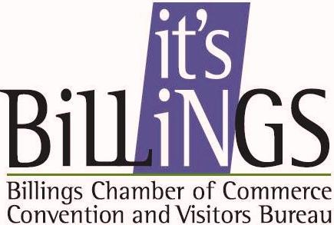 Visit Southeast Montana is managed by the Billings Chamber of Commerce/Convention & Visitors Bureau

